
The Forum of Women in the Environmental Field Presents:
Integrated Pest Management for Home Garden Practices
Wednesday, May 27th, 2009, 5:30pm-7pm
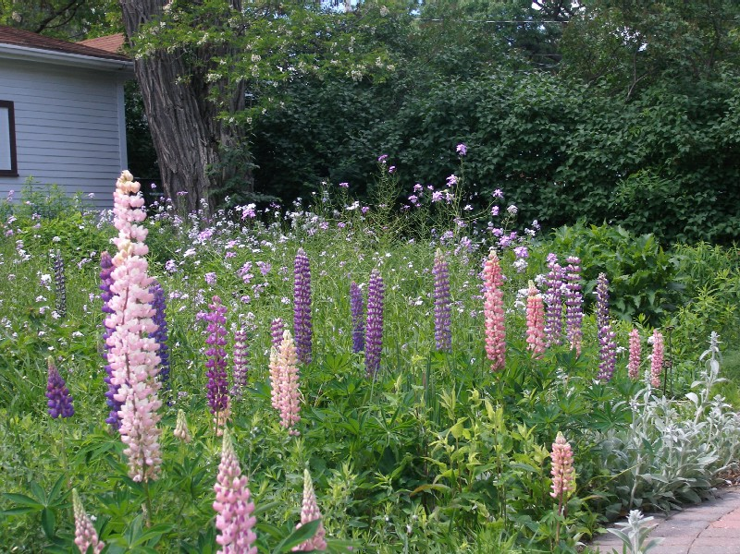
Explore Integrated Pest Management (IPM) and how you can apply it to your home gardening practices. IPM trainer Kevin Cavanaugh will lead a hands-on tour of St. Paul resident Debbie Meister’s yard. Learn about opportunities to help gardeners who have acres of plants, or a 3'x 8' urban balcony garden, or anything in between! Stay after the tour for networking around a backyard fire (weather permitting). A local meal will be provided by a local business using local foods!
Location: 1312 Portland Ave., St. Paul, MN
RSVP: by Monday, May 25th, 2009
Cost: is $18 ($12 for members, $10 for students)
Register online at: www.fwef.org

FWEF Event FWEF Event FWEF Event FWEF Event FWEF Event
IPM-Gardening IPM-Gardening IPM-Gardening IPM-Gardening IPM-Gardening
May 27th-evening May 27th-evening May 27th-evening May 27th-evening May 27th-evening
Register: fwef.org Register: fwef.org Register: fwef.org Register: fwef.org Register: fwef.org

